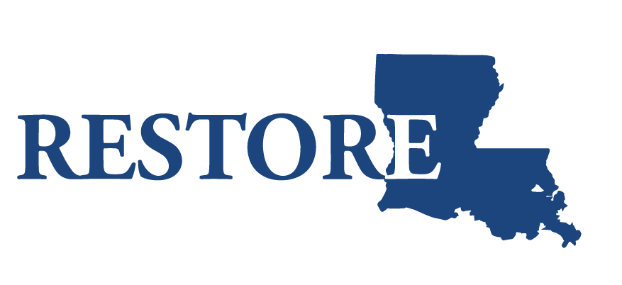
Nov. 2, 2017

FOR IMMEDIATE RELEASE

Contact: media@restore.la.gov

Loan Amount Forgiveness Increases, Deadline Extended for Restore La.
Small Business Assistance Program

BATON ROUGE, La. – Gov. John Bel Edwards’ Office of Community Development has made two important updates to the Restore Louisiana Small Business Program, which offers interest-free, partially forgivable loans to businesses impacted by the 2016 floods.

The interest-free loans available through the $43 million program range from $10,000 to $150,000. If qualified borrowers comply with all requirements, the loans are interest free. After recent program changes, 40 percent of the loan will now be forgiven when 60 percent of the principal is repaid. The previous forgivable amount was 20 percent.

In addition, OCD has extended the application period, and the exact deadline will be announced later. In the meantime, flood-impacted small businesses and nonprofits interested in a loan are encouraged to apply immediately through one of the participating lenders. A list of eligibility criteria is available here.

The Small Business Program is designed to help eligible businesses in the 51 parishes impacted by the March and August 2016 floods. The program has so far processed funding for $3.8 million in loans.

“We have about 200 applications going through the loan process now,” LaSonta Davenport, economic development manager with the Governor’s Office of
Community Development and the Restore Louisiana program, said. “Our data indicates there are many more business owners out there who were affected by the 2016 floods who could use assistance.”

The loans can be used for working capital—rent, mortgage, utilities, non-owner employee wages and inventory and movable equipment. However, construction-related expenses are not eligible.

Eligible borrowers are also referred to a local office of the Small Business Administration’s Small Business Development Centers. The centers offer technical expertise with business recovery and continuity plans, financial projecting and planning and disaster preparedness planning.

About the Restore Louisiana Task Force
The Restore Louisiana Task Force comprises 21 individuals from throughout the state who were appointed by Gov. John Bel Edwards to oversee the rebuilding process after historic flooding in March and August 2016 impacted 51 disaster-declared parishes. The Task Force’s mission is divided into six categories: community planning, economic, health and social services, housing, infrastructure and natural and cultural resources. All task force documents are available at http://restore.la.gov/resources/. For more information, visit restore.la.gov.

